SETTING UP AN AWS ROUTE 53

Route 53 is Domain Name System service, this document guides you on how to transfer an existing domain.

**Step 1:**

Navigate to you EC2 Instance and obtain the Public Facing IP

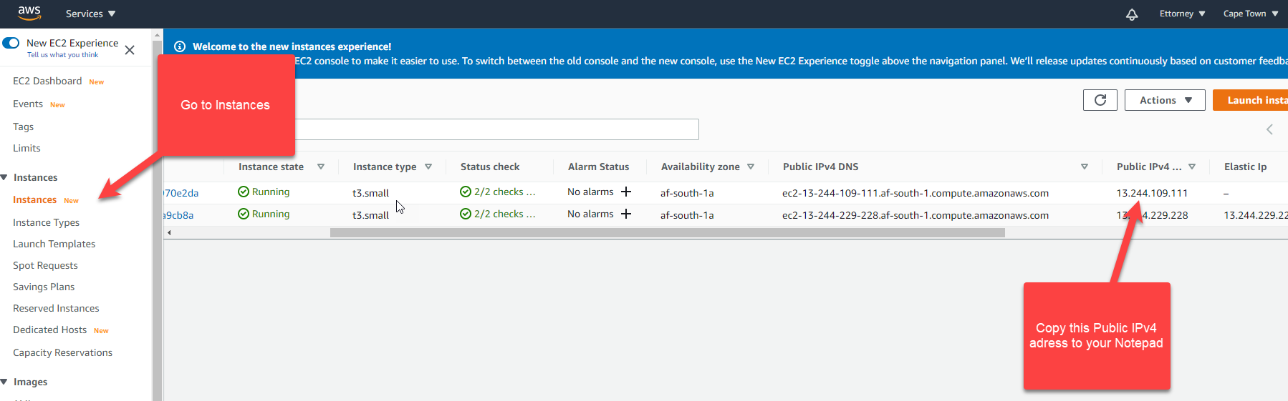

**Step 2:**

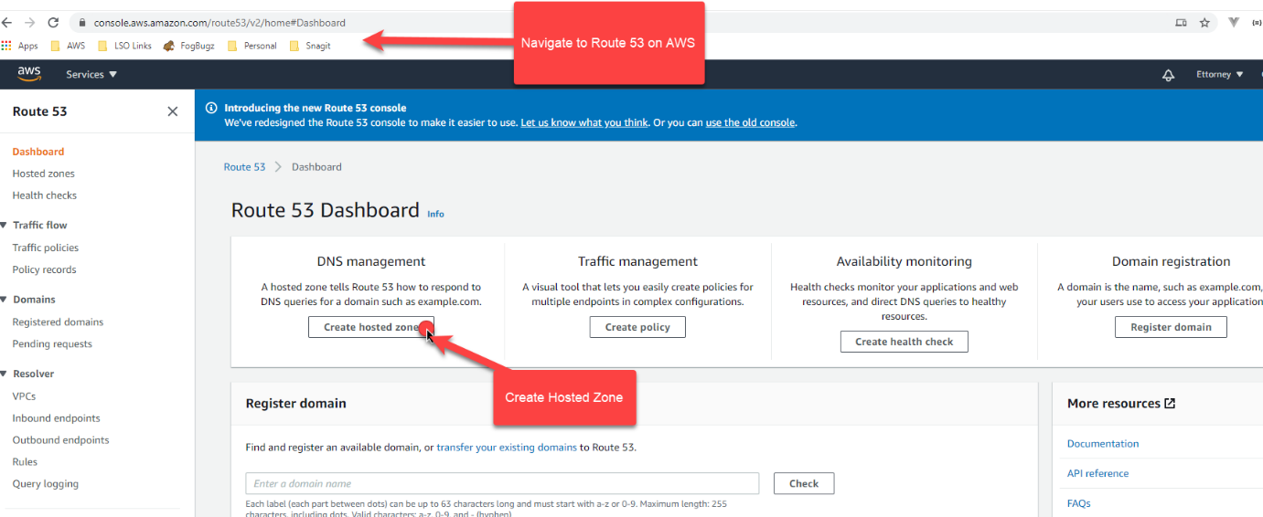

**Step 3:**

Ensure you are entering your own Domain Name.

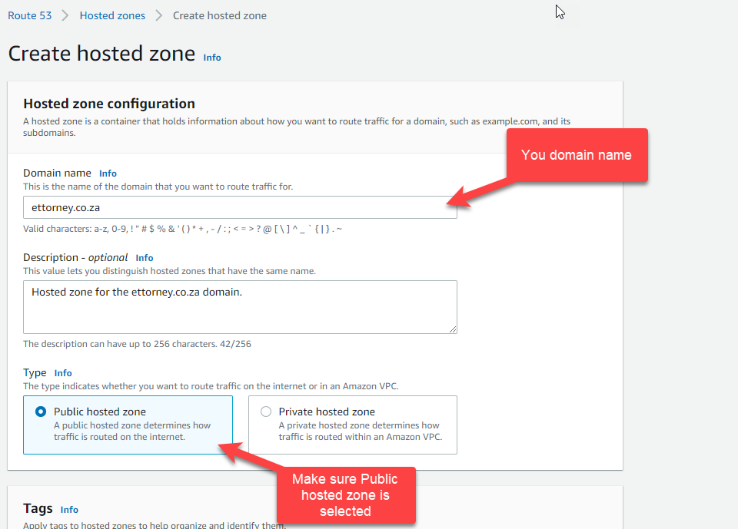

**Step 4:**

Create record.

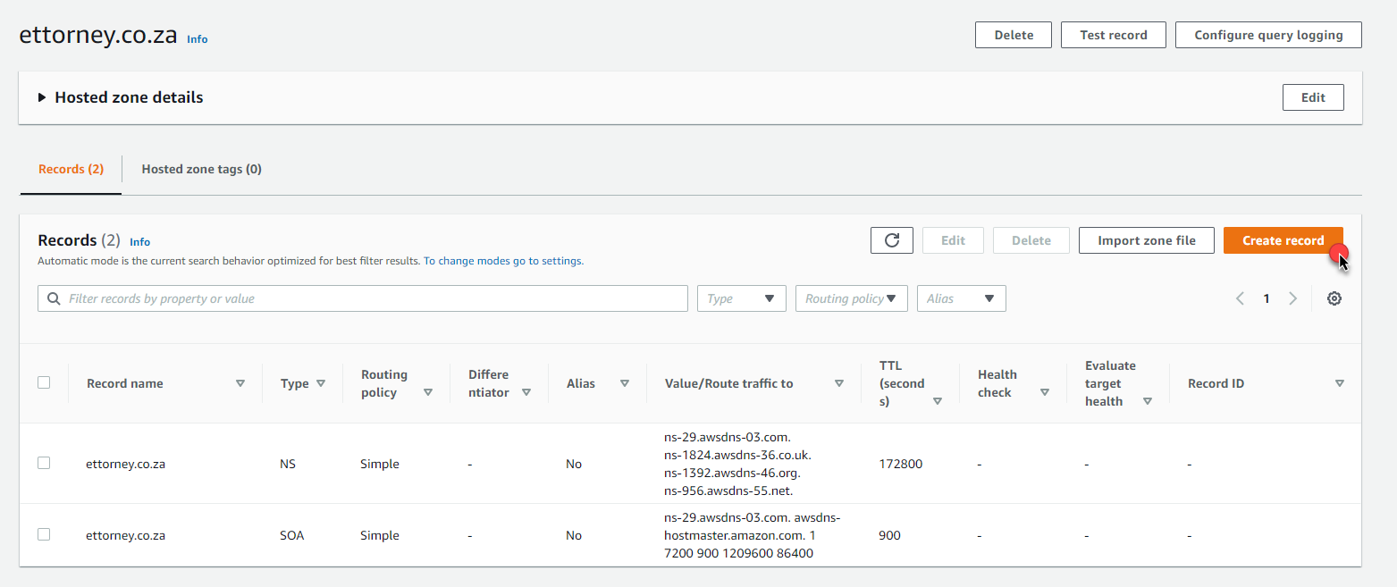

**Step 5:**

For this example we are creating a simple routing.

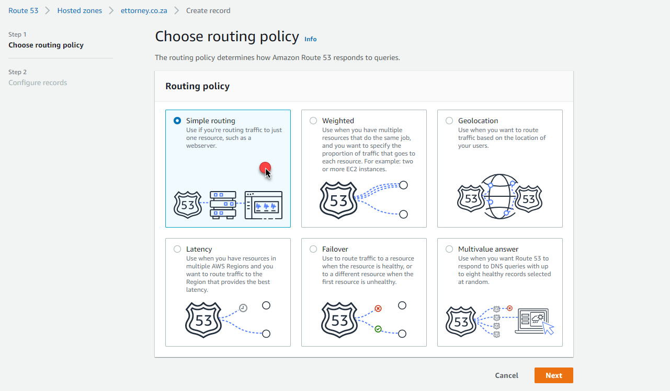

**Step 6:**

We are going to define two new simple records.

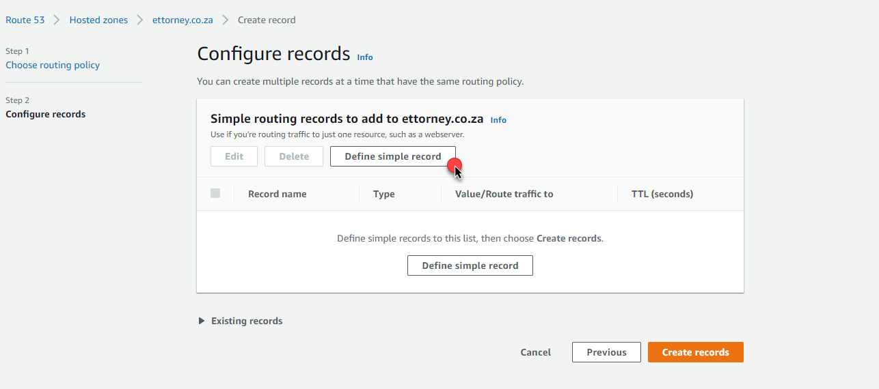

**Step 7:**

The First is a Record Type A

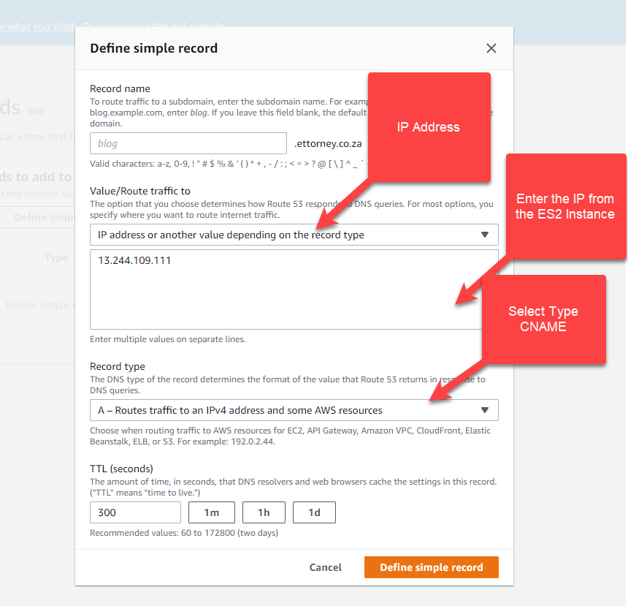

**Step 8:**

The Second is Record Type CNAME

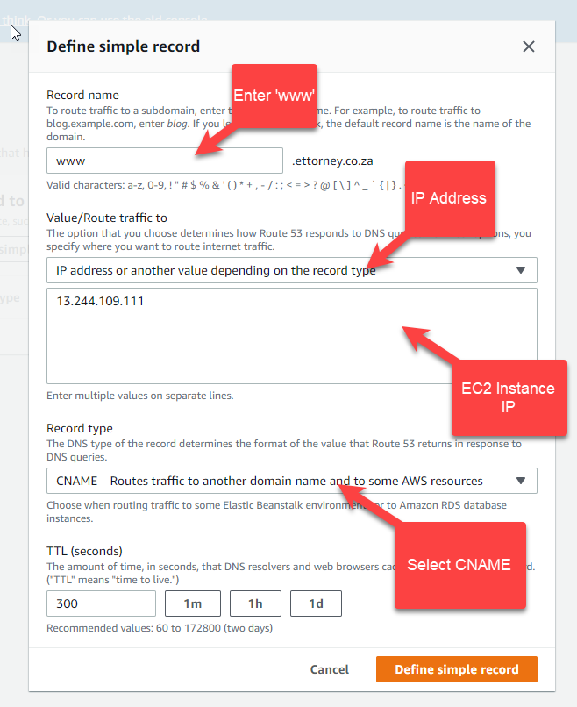

**Step 9:**

Now Create these Records

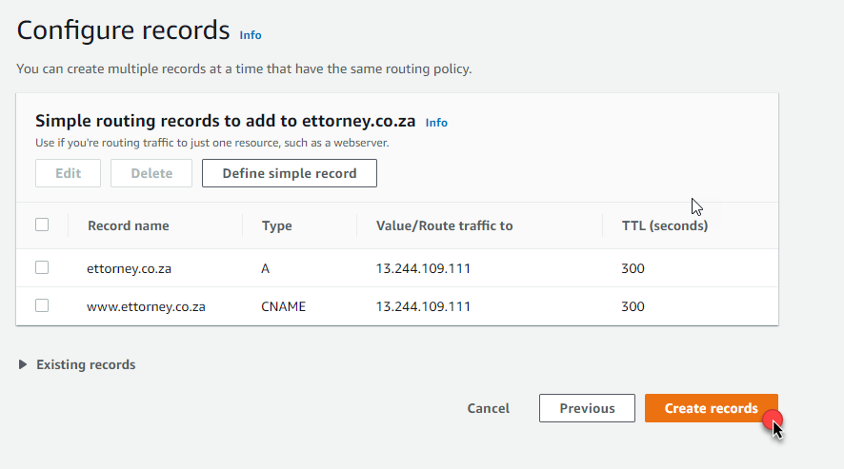

**Step 10:**

Once Created you need to Copy the following Name Severs.

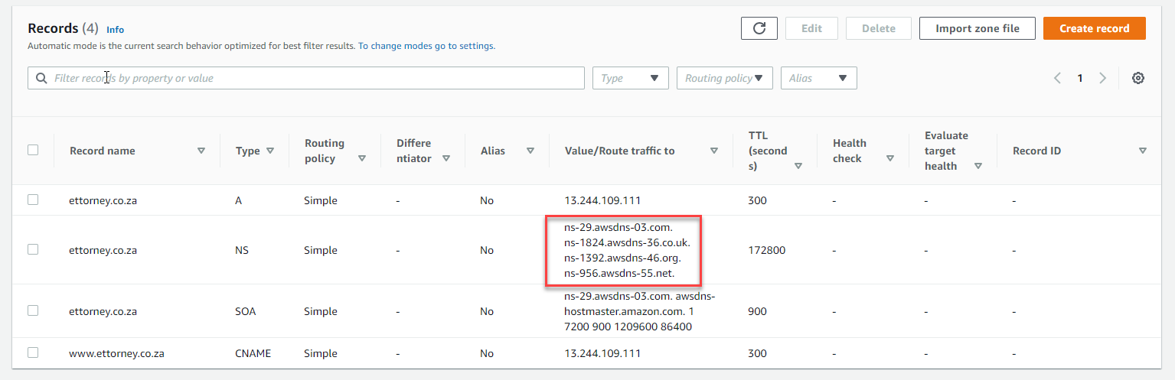

**Step 11:**

These Name Severs now needed to be added on where your domain is registered.  
They will be replacing the current name servers.  
  
If your Domain Registrar is Xneelo the only way to do this is emailing [*admin@xneelo.com*](mailto:admin@xneelo.com) requesting the Name Servers to be changed to the Name Servers you copied in Step 10.  
  
This process may take a few hours so make sure to do it during scheduled down time if need be.